From: <https://www.theepochtimes.com/ray-epps-told-fbi-he-expected-a-bomb-attack-near-the-capitol-on-january-6-documents-show_4655405.html?utm_source=partner&utm_campaign=ZeroHedge>

Via: <https://www.zerohedge.com/political/ray-epps-told-fbi-he-expected-bomb-attack-near-capitol-january-6-documents-show>

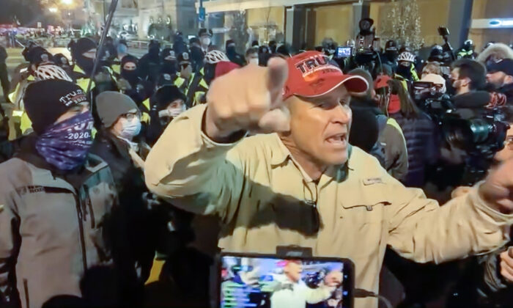

Ray Epps encourages protesters to go into the Capitol the night before the siege of January 6, 2021. (Villain Report/Screenshot via The Epoch Times)

[**US FEATURES**](https://www.theepochtimes.com/c-us-features)

EXCLUSIVE: Ray Epps Told FBI He Expected a Bomb Attack Near the Capitol on January 6, Documents Show

Epps admitted to trespassing, directing protesters to go into the Capitol. 'I wish I could take that back,' he told agents.

By Joseph M. Hanneman

August 12, 2022 Updated: August 14, 2022

[biggersmaller](javascript:void(0))

Print

When James Ray Epps Sr. first called the FBI regarding his January 2021 activities in Washington D.C., he didn’t mention how he implored protesters in several locations to go inside the Capitol, but he later told an agent that he expected a bomb would detonate on a side street near the Capitol.

Those are just two of the revelations in a collection of Epps-related material obtained by The Epoch Times [How?], including

* FBI interview summaries,
* FBI audio recordings,
* transcripts,
* videos, and
* photographs.

In two interviews with the FBI in 2021, Epps explained his actions on Jan. 5 and Jan. 6. **He admitted he was guilty of trespassing on restricted Capitol grounds and confessed to urging protesters to go to—and into—the Capitol on Jan. 6.**

Despite the admissions, the FBI never arrested Epps and he was not charged by the U.S. Department of Justice with any Jan. 6 crimes. The non-action has fueled a crop of theories that he might have been working for the FBI or another agency.

Epps, 61, has [repeatedly denied](https://www.theepochtimes.com/exclusive-ray-epps-attorney-a-former-fbi-agent-says-his-client-is-no-fed_4208214.html) those suggestions through his attorney.

Epps recently sold his house and land in Queen Creek, Arizona, because of threats and harassment and moved to Colorado, he told the New York Times in July. According to online records, the Arizona property sold for $2.2 million on April 28, 2022.

Epps at one time was No. 16 on the FBI’s Jan. 6 most-wanted page. His entry was later scrubbed from the list without explanation. He is among a handful of persons of interest to have their [photos deleted](https://www.theepochtimes.com/3-babbitt-shooting-witnesses-removed-from-fbi-most-wanted-list_4250599.html) from the FBI site.

**‘Like a Terrorist Act’**

In an interview with FBI agents on March 3, 2021, Epps said he brought a first-aid kit in his backpack to Washington because he expected a terror attack.

“Yeah, I thought there might be a problem. That’s why I was there,” Epps told an FBI agent and an FBI Joint Terrorism Task Force officer in a meeting at the Phoenix office of Epps’s attorney, John Blischak.

Blischak told The Epoch Times he would comment after reviewing the FBI interview summary, but had not done so by press time.

“I was afraid they were going to set off an explosion on one of the side streets,” Epps said, according to a recording of the interview obtained by The Epoch Times. “So we tried to stay in the middle, tried to get there early, tried to stay away from the sides. And if something like that happened, I had a first-aid kit. I could help out.” [Right! -FNC]

Epps told the agents the possibility of violence weighed heavily on his mind and he originally did not plan to travel to Washington. It was only when learning that his son, James Epps Jr., was going to the Trump rally that the senior Epps decided to go and keep an eye on his son, he said. [Right! -FNC]

[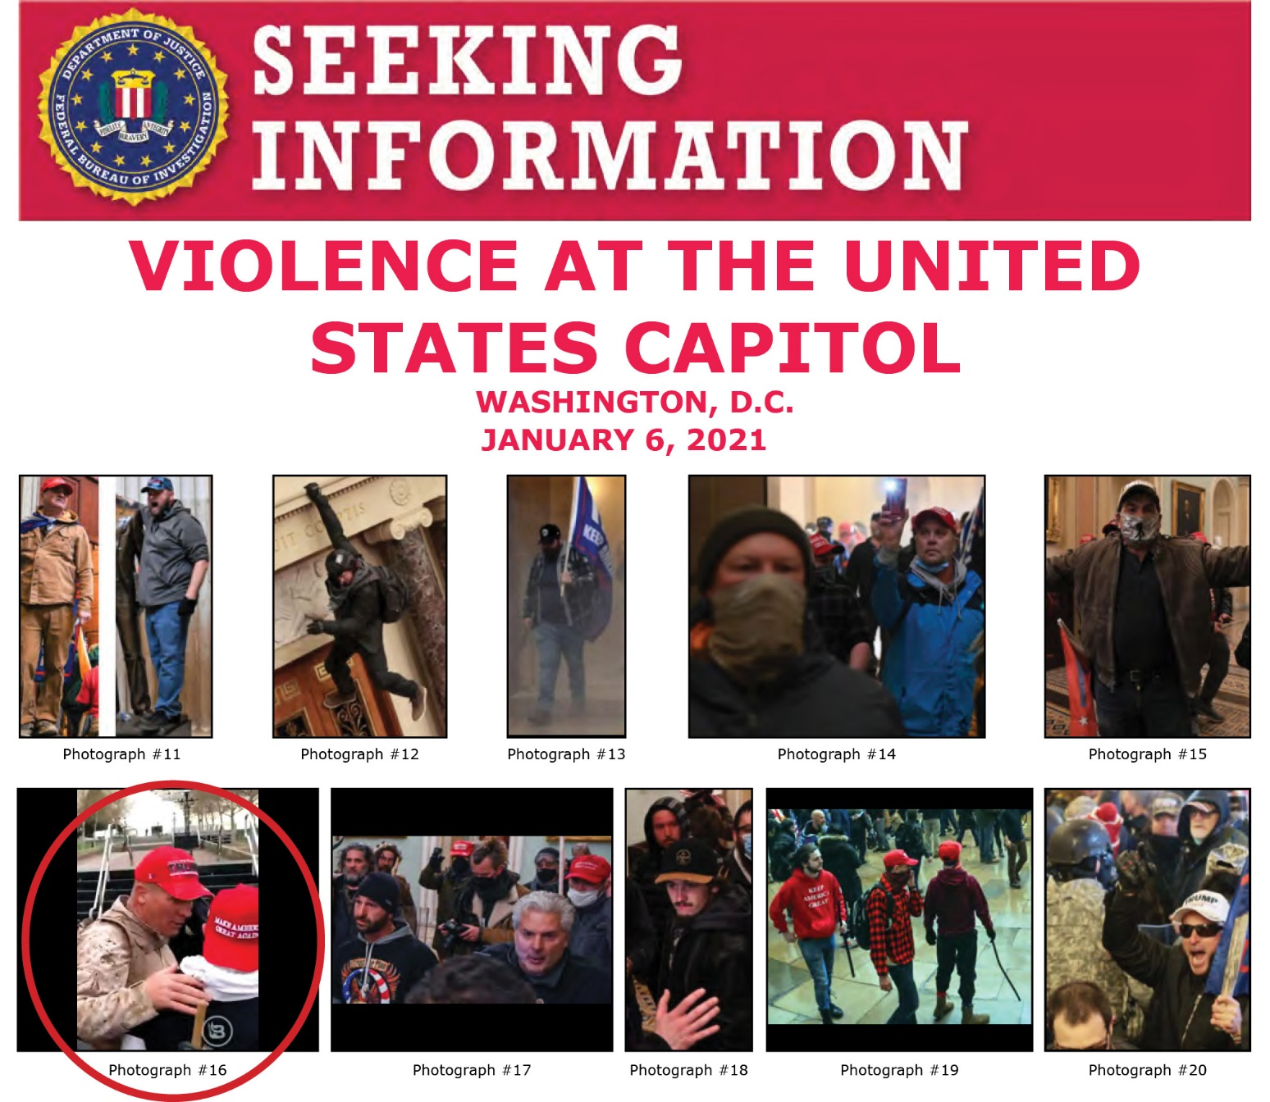](https://img.theepochtimes.com/assets/uploads/2022/01/05/Epps_Poster-1200x1042.jpg) Ray Epps is shown at the lower left on an early FBI “wanted” poster. His photo has since been scrubbed from the FBI website. (FBI.gov/Wayback Machine)

“As time went on, I started getting a bad feeling like something’s gonna happen,” said Epps, a U.S. Marine Corps veteran and former Oath Keepers leader in Arizona. “There’s a lot of wackies out there. I thought something would happen in D.C. I thought there might be, what do they call them, EOD, something like that?” [Right! -FNC]

Epps might have been referring to an improvised explosive device (IED), which is a homemade bomb that was a favorite weapon of insurgents in Afghanistan during the United States’ long war there. In military parlance, an EOD refers to an explosive ordnance disposal specialist—someone who defuses and destroys explosives.

An agent asked for clarification: “Oh, you mean like a terrorist act?”

“Right, like a terrorist act,” Epps said. [Right! -FNC]

The agents did not press Epps on what led him to believe there would be an explosion, nor did they ask about the two alleged pipe bombs found outside the Republican and Democrat party headquarters, each just blocks from the Capitol. The RNC [pipe bomb](https://www.fbi.gov/contact-us/field-offices/washingtondc/news/press-releases/fbi-washington-field-office-releases-video-and-additional-information-regarding-the-pipe-bomb-investigation-090821) was placed near the corner of the Capitol Hill Club facing a side street, similar to the description Epps offered.

The devices did not detonate and the FBI has not arrested anyone in those cases.

Epps told the FBI he regretted the things he said in downtown Washington the night of Jan. 5, 2021. He spoke to internet personality Baked Alaska and video podcaster Villain Report, both of whom recorded their exchanges.

“In fact tomorrow, I don’t even like to say it because I’ll be arrested. …I’ll say it. We need to go into the Capitol,” Epps told Baked Alaska, whose legal name is Anthime Gionet.

Epps shouted a similar theme to the crowd at large: “Tomorrow, we need to go into the Capitol. Into the Capitol. Peacefully,” he said. The crowd then started chanting, “Fed! Fed! Fed! Fed!”

The FBI agents told Epps that his statements on Jan. 5 were problematic. They said they found him often on video and in photographs from Jan. 5 and 6.

Epps replied: “I’m the tallest guy in the crowd, and I stick out, man. They followed me.” Then he joked, “I could never be a bank robber.”

“We said that the same way,” one of the agents said. “We said, ‘It’s a big guy and every photo we find, he’s in it.’ The night before, that video didn’t help.

“…And the video the night before, what you said basically predicted what happened,” the agent said.

“I wish I could take that back,” Epps replied. He called the statements “really stupid.”

On Jan. 6, Epps was filmed near the Washington Monument imploring the crowd, “We are going to the Capitol, where our problems are. It’s that direction. Please spread the word.”

When speaking to a young man in a red and black mackinaw jacket, Epps said, “When we go in, leave this here [pointing to something]. You don’t need to get shot,” according to a video of the exchange. [This whole dialog is clearly a scripted interview for subsequent release when/if needed! -FNC]

**First Call to FBI on Jan. 8**

Epps first called the FBI on Jan. 8, 2021, after his brother-in-law notified Epps’s wife that a photograph of Epps was on the FBI website. That call to the National Threat Operations Center (NTOC) lasted about 27 minutes, according to an audio file of the call obtained by The Epoch Times.

In describing his activities, Epps never mentioned that he urged the crowds on Jan. 5 to go into the Capitol the next day. He said he went down to Black Lives Matter plaza to try to calm things down after people he suspected were Antifa activists were harassing police.

“I tried to calm them down,” Epps told the FBI operator. “I tried to let them know that, you know, that this is not what we’re here for. We’re here because of the Constitution, not the police. Police are on our side.”

Nor did Epps mention getting on a bullhorn on Jan. 6 and encouraging people to go to the Capitol as soon as President Donald Trump was finished speaking. He would comment on those topics nearly two months later when interviewed by FBI agents.

On the January call, Epps insisted his presence on Capitol grounds was to de-escalate when things got violent.

“I am guilty of being there and probably trespassing,” he said. “But I had a reason. I was trying to calm ’em down. I wanted to be there, but I’m trying to calm ’em down. Anything I can do to help. There’s no call for that kind of behavior. I will be your witness.”

[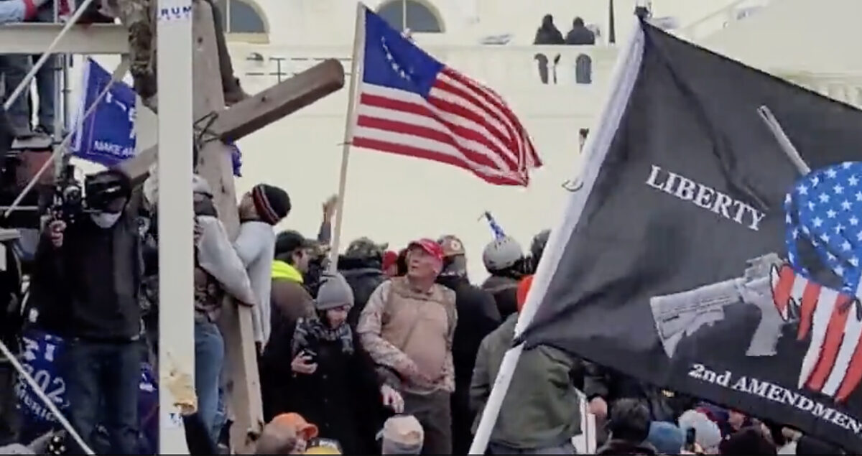](https://img.theepochtimes.com/assets/uploads/2022/01/05/Epps_on_Video-1200x635.jpg)   
Ray Epps at the U.S. Capitol on Jan. 6, 2021, shortly before pepper gas is shot into the crowd. “Been a long time,” he said. “Aah, I love it!” (Screen Capture/Rumble)

Epps told the agents he came to Washington to express his concerns about the 2020 presidential election. He said he received five ballots at his Queen Creek address: one each for him and his wife, and three with names he did not recognize.

“We’ve owned the property for 11 years now. I’ve never heard of those three people that came there. I didn’t recognize the names,” he said. “And then when the election went the way it did, I was a little concerned. I mean, how many apartments are there in Arizona, 3 million? And if they’re sending all these ballots to these different apartments. I mean, you know, that’s a concern.”

Epps said he also went to support Trump, although he did not stay at the Ellipse for all of  Trump’s speech. He said he followed crowds that left the speech early and walked toward the Capitol.

“People started leaving early after President Trump started speaking. So they were running and it was the same people that was, ‘F Antifa,’ and this and that and the other,” Epps said.

“I believe, just my belief, they were Antifa, the ones that were saying that stuff,” he said. “And they were like running that way and I’m like, ‘Maybe I can calm this down.’ So I went with them.”

Epps said it was his original intention to stay for all of the speeches at the Ellipse.

“I planned on being and word was being passed around that right after he gets done speaking, we’re gonna go to the Capitol. And it was a given,” Epps said. “So spread the word spread the word. So I started spreading the word and I said that to a lot of people there: ‘We’re going to the Capitol right after the president speaks.'”

[t seems clear that Ray Epps has been working hand-in-glove with some part or parts of the Deep State before, during, and after the January 6 DC event. The whole dialog reported here appears to be a scripted interview assembled for subsequent release when/if needed!

1. He had been an "Oath Keepers leader in Arizona". [Search](https://www.google.com/search?q=%22oath+Keepers%22+rotting+in+jail&oq=%22oath+Keepers%22+++rotting+in+jail&aqs=chrome..69i57.12805j0j15&sourceid=chrome&ie=UTF-8)
2. The January 5, 6 mission he was on in DC is totally unrevealed and with this article more completely hidden by this FBI performance.

-FNC]

Perhaps the scene that drew the most attention and speculation about Epps on [January 6](https://www.theepochtimes.com/t-january-6) was when he appeared at the first breach point of police lines. Some 20 minutes before Trump finished speaking at the Ellipse, an aggressive crowd gathered at a lightly defended barrier on a sidewalk not far from the Peace Monument.

As rioters began yanking at the bicycle-rack barriers, Epps pulled Ryan Samsel back from the front line and spoke in his ear. Seconds after that exchange, Samsel and others knocked down the barrier, causing one officer to fall back and hit her head on the concrete.

“I walked up to him, and I put my arm on him and said, ‘Hey, that’s not why we’re here. Don’t be doing that,’ you know.

“I don’t know who he was. No clue,” Epps said. “I just tried to talk him out of doing what he was doing. And then all of a sudden, it blew up.”

When interviewed by an FBI special agent and a detective on Jan. 30, 2021, Samsel corroborated Epps’s description of their brief verbal exchange, according to a transcript of the session obtained by The Epoch Times. Samsel faces nearly a dozen January 6-related charges in U.S. District Court in Washington.

“Now that guy I talked to,” Samsel said, pointing to a photograph of Epps. “He came up to me and he says, ‘Dude,’ his exact words were, ‘Relax,’ he says, ‘The cops are doing their job.’ That’s exactly what he says to me right there in that picture.”

**Inconsistencies in Interviews**

Epps’s two interviews with the FBI included some inconsistencies and changed details, according to the recordings and FBI summary documents.

Epps told the FBI on Jan. 8 that his brother-in-law called him to notify him his picture was on the FBI’s January 6 website. During his March 3 interview with FBI agents, Epps said, “Someone contacted me and said, ‘Hey, your picture’s up.’”

When asked about his brother-in-law later in the interview, Epps said, “He didn’t call me, he called my sister.” Then his wife interjected, “That was me. And I can tell you exactly because he sent me a text, actually.”

When asked about who was with him on Jan. 5 and 6, Epps replied, “My son.” A short while later he said, “I think he had a friend there. He did have a friend there. I don’t know his name.”

One of the agents said he recalled that on the Jan. 8 phone call with the FBI, Epps said he went sightseeing on Jan. 7. “No, we did that the day before,” he told the agent. A few minutes later, however, this detail changed. “Oh, you know what? The next day we did, no, we got up that morning and we went to the Vietnam Memorial.”

In both contacts with the FBI, Epps asked if his photo could be removed from the FBI’s Jan. 6 page. In the Jan. 8 call, the FBI operator said she had nothing to do with FBI web content. In the March 3 interview, he was given a more discouraging take.

“That picture is probably still out there, will probably be there forever now,” one of the agents told him.

Epps said the notoriety of being publicly listed as a person of interest had caused problems.

“Well, we’ve felt the repercussions. I mean, we’ve had people come on our business site and try to destroy us,” he said. “I’m an insurrectionist, I’m a traitor. I’ve been called everything in the book, but it’s dying down now—I hope.”

The agents asked Epps if his views had changed since Jan. 6.

“I still have concerns about the election. I do. I mean, I think everybody does,” Epps said. “I think our politicians, some of them need to be in jail. I think you guys need to investigate them. I don’t know. How much of what we get is the truth? I don’t know. Not even worth watching the news anymore. Because they just make it up as they go.”

Epps met twice with the House of Representatives’ Jan. 6 Select Committee, including a transcribed interview in January 2022. Committee members seemed satisfied with what Epps told them. No transcript of the session has been released.

“Mr. Epps informed us that he was not employed by, working with, or acting at the direction of any law enforcement agency on January 5th or 6th or at any other time, and that he has never been an informant for the FBI or any other law enforcement agency,” a spokesman said in January.

Sen. Ted Cruz (R-Texas) grilled top FBI officials about Epps in a January hearing, but received a repeated refrain: “I can’t answer that.”

Twitter: Joseph M. Hanneman is a reporter for The Epoch Times with a focus on the Jan. 6 U.S. Capitol incursion and its aftermath; and general news in the State of Wisconsin. His work over a nearly 40-year career has appeared in Catholic World Report, the Racine Journal Times, the Wisconsin State Journal and the Chicago Tribune. Reach him at: joseph.hanneman@epochtimes.us

[](https://www.theepochtimes.com/author-joe-hanneman)

[Joseph M. Hanneman](https://www.theepochtimes.com/author-joe-hanneman)

Follow

Joseph M. Hanneman is a reporter for The Epoch Times with a focus on the Jan. 6 U.S. Capitol incursion and its aftermath; and general news in the State of Wisconsin. His work over a nearly 40-year career has appeared in Catholic World Report, the Racine Journal Times, the Wisconsin State Journal and the Chicago Tribune. Reach him at: joseph.hanneman@epochtimes.us